H2 21BIT269D

# Experiment 9

*Aim:* Create simple cards using Material UI and React. Use animations to make it more attractive

1) In components folder, add some cards from the MUI website

## 2) Update the *App.js* to add the cards

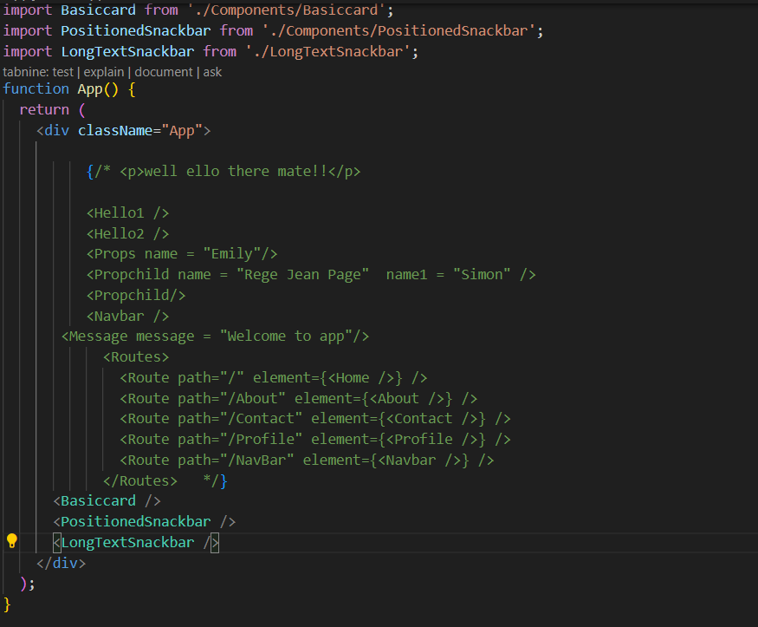

H2 21BIT269D

## **OUTPUT**

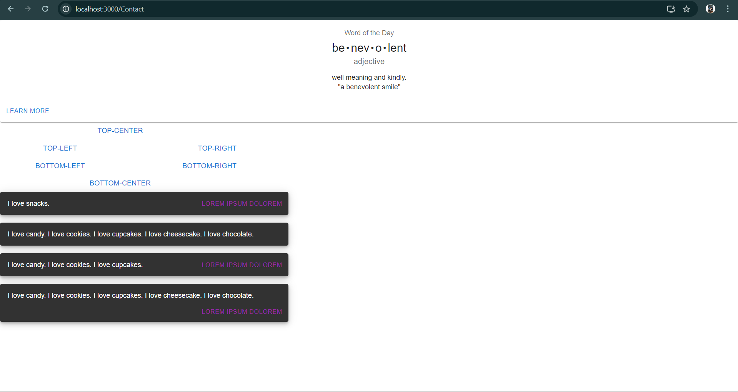

**Discussions:**

This experiment delves into enhancing user engagement and aesthetics by employing Material-UI cards in a React application, augmenting their appeal through animated transitions and effects, thereby enriching the overall user experience.